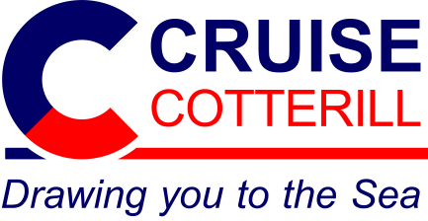
Guest Blogger
Application Form

Title: |  | First Name: |  | Surname:

Blog / Website Name:
Blog / Website Address:
Blog / Website Facebook:
Blog / Website Twitter:
Blog / Website YouTube:
Blog / Website Instagram:

Please write a short bio about yourself and your blog / website (100 – 150 word)

Which country do you live in?
How many cruises have you been on?

Please put a cross (X) next to the destinations you have visited on a cruise
Africa |  | Alaska |  | Antarctica
Asia |  | Australasia |  | Baltic Sea
Canada |  | Caribbean |  | Europe
Mediterranean |  | Middle East |  | Norway
Panama Canal |  | South America |  | USA

Please put a cross (X) in the box next to the subjects would you be interesting in writing blogs or articles about
Articles about a destination you have cruised to
Articles about a particular cruise ship
Articles about a particular cruise line
First time cruisers tips and advice
Top cruise tips
Money saving tips and advice

